- TE10 Mode Simulation: A WR-90 rectangular waveguide has a = 22.86 mm, b = 10.16 mm and length L = 100 mm. Operate it at f = 10 GHz and excite the dominant TE10 mode in HFSS. Obtain the E-field and H-field distributions, simulated cutoff frequency fc and propagation constant β. Calculate fc (theory) = c/(2a), β = (2πf/c)√[1−(fc/f)²], and the percentage deviation of simulated fc from theoretical fc. 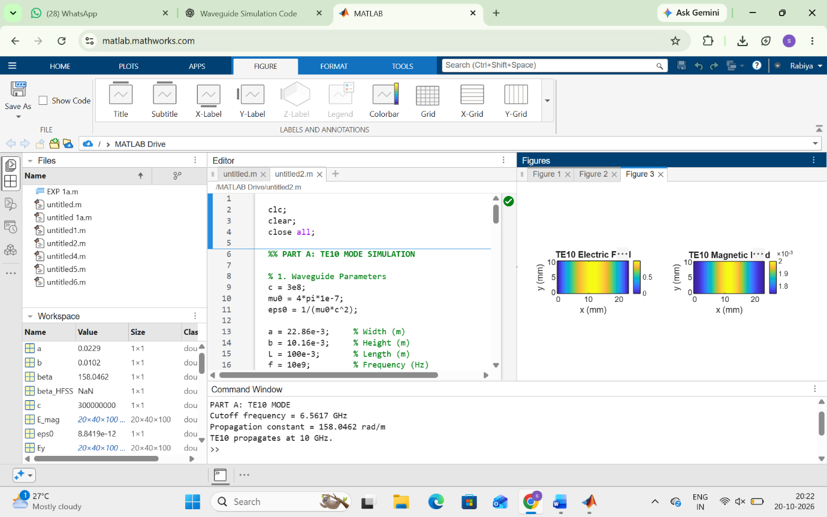
- 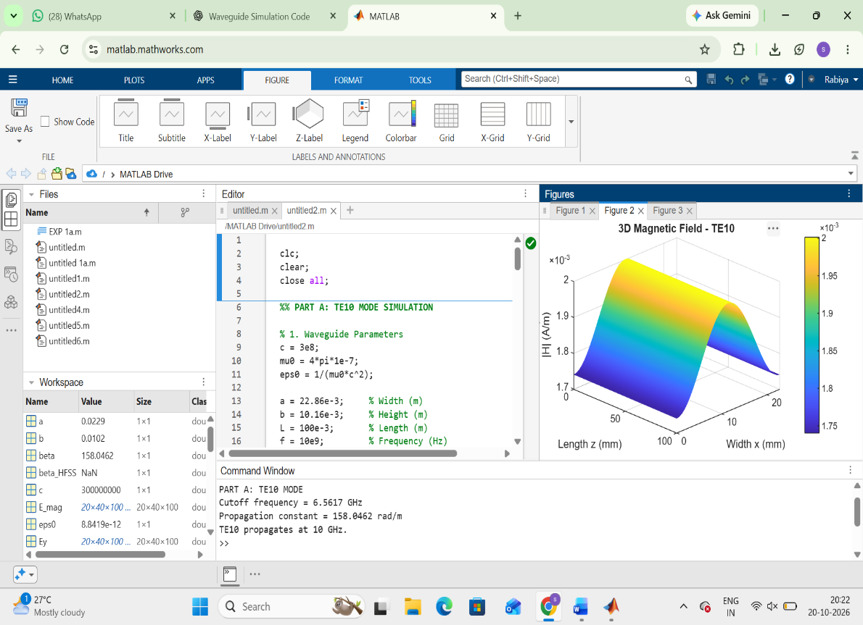

TE10 versus TM11: Using the same WR-90 waveguide at f = 10 GHz, simulates both TE10 and TM11 modes. Determine fc, β and the E/H-field distributions for each mode. Calculate the theoretical cutoff frequencies using fc(mn)=c/2√[(m/a)²+(n/b)²]. Compare the results and justify why TE10 propagates at 10 GHz while TM11 does not.
S.No. | Output Parameter | Theoretical / Expected Value | Practical / Simulated Value | % Deviation
1 | E-field distribution | TE10/TM11 field pattern | Record HFSS plot | —
2 | H-field distribution | TE10/TM11 field pattern | Record HFSS plot | —
3 | Cutoff frequency | TE10 = 6.557 GHz; TM11  ≈ 16.42 GHz | Record HFSS value | % deviation
4 | Propagation constant | TE10 ≈ 198.9 rad/m at 10 GHz | Record HFSS value | % deviation
5 | Mode decision | TE10 propagates; TM11 is below cutoff | Record observation | —
